Doug Strouth  
CIS228

Chapter 6 City Jail

**The head DBA has requested the creation of a sequence for the primary key columns of the Criminals and Crimes tables.**

CREATE SEQUENCE criminal_id_seq

INCREMENT BY 1

START WITH 1017

NOCACHE

NOCYCLE; 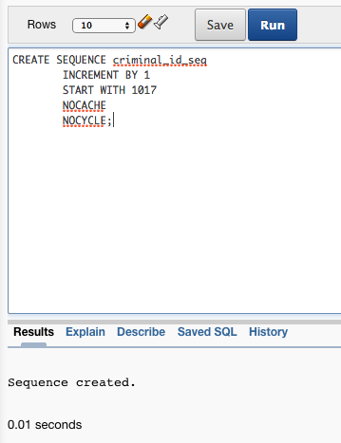

CREATE SEQUENCE crime_id_seq

INCREMENT BY 1

START WITH 1

NOCACHE

NOCYCLE;

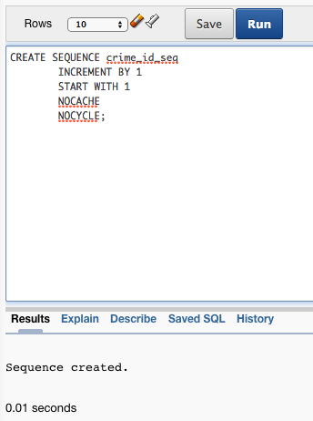

**After creating the sequences, add a new criminal named Johnny Capps to the Criminals table by using the correct sequence. (Use any values for the remainder of columns.)**

INSERT INTO Criminals (criminal_id, first, last, city, state, zip)

VALUES (criminal_id_seq.NEXTVAl, 'Johnny', 'Capps', 'Worcester', 'MA', 01603);

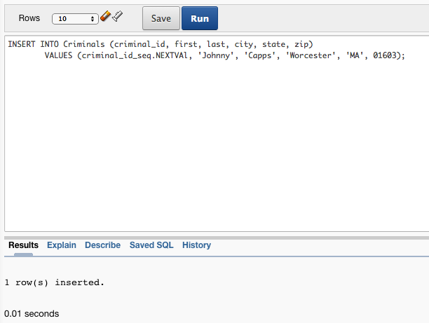

**A crime needs to be added for the criminal, too. Add a row to the Crimes table, referencing the sequence value already generated for the Criminal_ID and using the correct sequence to generate the Crime_ID value. (Use any values for the remainder of columns.)**

INSERT INTO Crimes (crime_id, criminal_id)

VALUES(crime_id_seq.NEXTVAl,criminal_id_seq.CURRVAl);

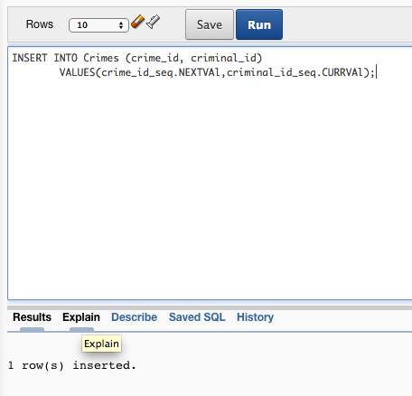

**The last name, street, and phone number columns of the Criminals table are used quite often in the WHERE clause condition of queries. Create objects that might improve data retrieval for these queries.**

CREATE INDEX criminal_name_idx

ON Criminals (last);

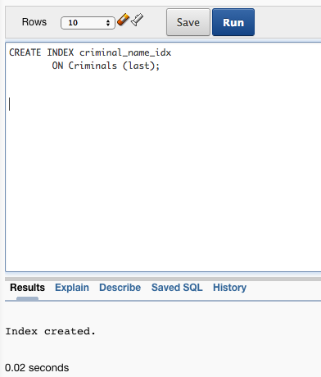

CREATE INDEX criminal_street_idx

ON Criminals (street);

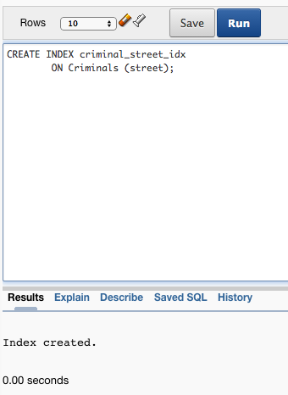

CREATE INDEX criminal_phone_idx

ON Criminals (phone);

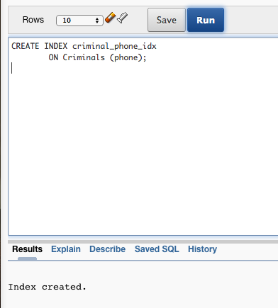

**Would a bitmap index be appropriate for any columns in the City Jail database (assuming the columns are used in search and/or sort operations)? If so, identify the columns and explain why a bitmap index is appropriate for them.**

V_status and p_status in the Criminals table, Classification and Status in the Crimes table, Precinct in the Officers table, and Charge_status in the Crime_charges table are all excellent choices for columns to have bitmap indexes. this is because they have a set number of possible values which are not likely to change in the future.

**Would using the City Jail database be any easier with the creation of synonyms? Explain why or why not.**  
  
Since we can assume that people from very different parts of the City Jail are going to be interacting with the database and entering data into the objects they own, while still wanting to query those they don’t, it would be useful to assign public synonyms to most of the tables. This would come down to which tables the DBA would like to restrict to only users who know the schema they are saved to such as financial records for prisoners or the list of arresting officers in case a criminal gained access to the database and wanted their home addresses. Other tables like Criminals, Aliases, Crimes, and Sentences should have synonyms.